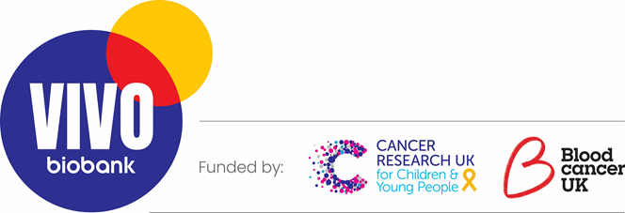

Application Form:

VIVO Biobank Patient and Public Involvement (PPI) Working Group

How to apply:

We hope you find this process simple, but if you need any help with filling in the form or need an accessible version, please email us on involvement@vivobiank.org.

- At VIVO Biobank, we're committed to creating an inclusive space to involve all people affected by cancer, irrespective of their race, ethnicity, disability, sexual orientation, gender, age, religion or belief. We actively encourage applications from people of all backgrounds and cultures and believe that a range of views and insight will help us represent all people affected by cancer. We expect everyone to work with and respect each other’s experiences and needs.

- We often receive more applications for patient involvement roles than we have spaces available, so we’d like to know a bit about you and your experiences. To be fair to applicants, we will assess candidates based on the requirements in the role profile. The information you share in your application will help us in making shortlisting decisions if needed. There are no right or wrong answers. Please answer to the best of your ability. The suggested word limit for each question is about 200 words.

- This application requires you to share with us sensitive information about yourself, which are covered under Data Protections Laws. These questions are optional and please only provide this information if you are comfortable doing so. We believe that it is necessary for us to process it in order to ensure 'equality of opportunity or treatment in the public interest' as set out in the Data Protection Act 2018.
We will keep this information confidential unless you provide us with explicit consent to share your story for a specific purpose whilst working with us.

- You can find out more information about how we store and might use your information in our privacy policy.

- Please complete the form below (either typed, or hand written and scanned/photographed) with the Equal Opportunities Monitoring form and email it back to us by 02/12/2022 at involvement@vivobiobank.org. If you have any questions, please feel free to contact us.

Your Details:

Your details are safe with us. We will never share them with anyone else. You can check out our terms and privacy policy here.

Personal information and details
Name:
Age group (please select): | ☐ 16 – 17*  ☐ 18 – 25  ☐ 26 – 40  ☐ 41 +  * under 18’s must provide written consent from their guardians with their application.
Town/city:
Devolved United Kingdom nation:
(England, Northern Ireland, Scotland or Wales)
Phone number:
Email:
Preferred contact method (phone or email):

About you
Please tick or highlight all that apply:

☐ I have/had a diagnosis of childhood, teenage or young adult cancer

☐ My child / sibling / close family member / friend has had a diagnosis of childhood, teenage or young adult cancer

Please tell us a bit more about yourself and, if relevant, your experience of cancer (e.g. cancer type, treatment etc.) if you feel comfortable:

1) Why are you interested in this role? (E.g. Is there something about this specific area of cancer, or being involved in a Review Panel as a Representative, that particularly interests you?)

2) Each person’s cancer experience is different. Please tell us about which area of childhood, teenage and young person’s cancer you’re particularly interested in and explain why?

3) It is important that the group can work well together. What additional skills and experiences do you feel you would be bringing to the role?
For example, this might be examples from your personal life, cancer experience, paid or voluntary work or training and other life experiences, and cover areas such as communication skills, being able to provide constructive feedback and representing the views of a diverse range of people. You may want to refer to the role description as it lists the types of skills and experiences that we are looking for.

4) There will be opportunities for 2-3 members of the working group to sit on the Biobank’s Management Group and/or Steering Committee. Would you be potentially interested in these roles? (further information will be provided at interview)

☐Yes
☐No
☐Not sure

Interview: If your application is successful, you will be invited to a telephone/online Microsoft Teams interview held around the 9th - 16th of December

If you have a preference due to existing commitments, please let us know below. We expect interviews to last roughly 30 minutes each.

