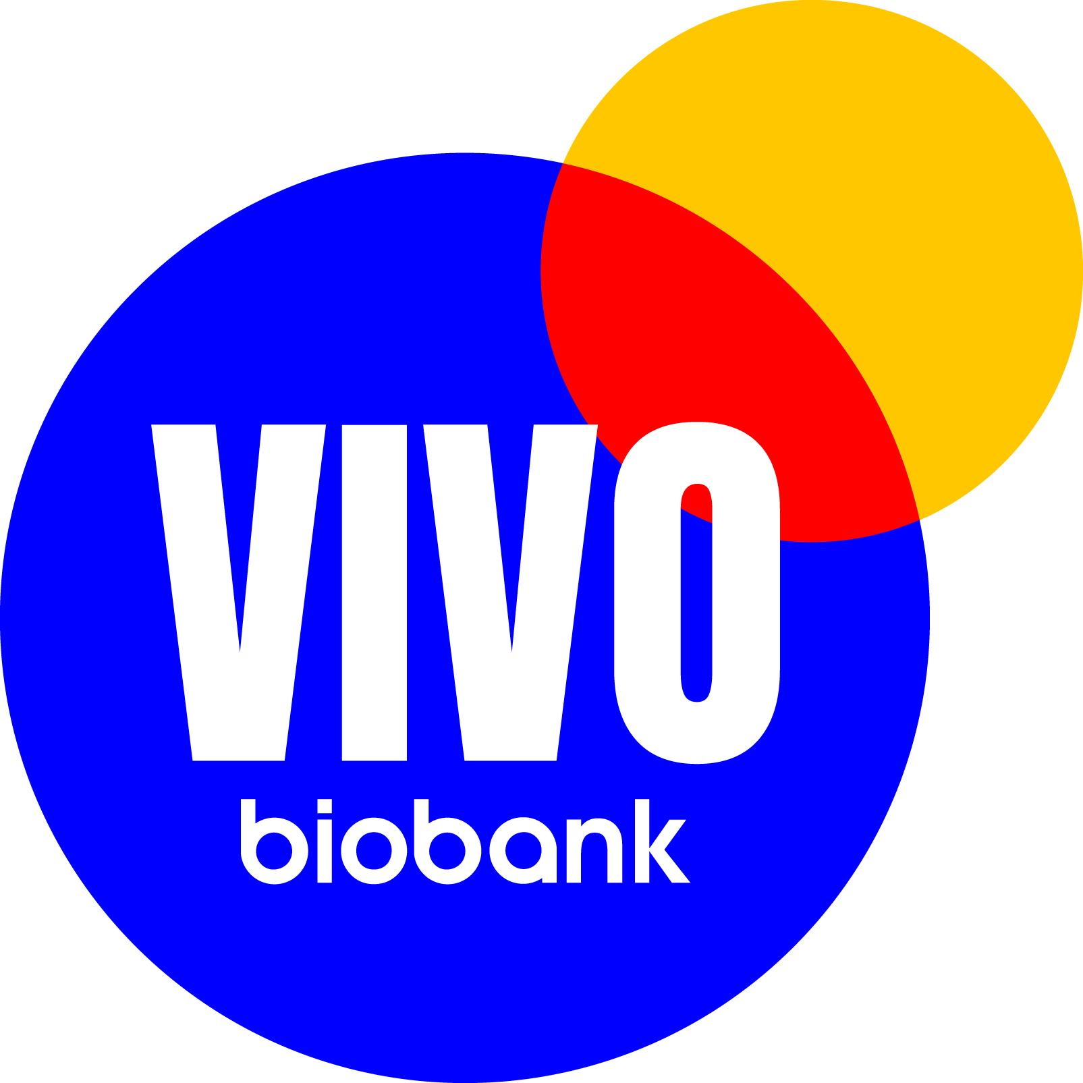

MATERIAL TRANSFER AGREEMENT

(FOR THE SUPPLY OF TISSUE MATERIALS FROM VIVO BIOBANK FOR RESEARCH PURPOSES ONLY)

BETWEEN:

- Newcastle University a charitable organisation established of Durham and Newcastle under the Universities of Durham and Newcastle upon Tyne Act 1963, a statute of England, whose address for service is King’s Gate, Newcastle upon Tyne, NE1 7RU (“Newcastle”); and

(2) [Insert name of Institute receiving material] whose address for service is [Insert address] ("the Recipient")

Individually referred to as a Party and together as the Parties.

BACKGROUND

(1) VIVO Biobank is a merger of the former CCLG Tissue Bank and the former Blood Cancer UK Childhood Leukaemia CellBank. VIVO Biobank has guardianship of various Materials and associated information collected from children and young adults diagnosed with cancer. The VIVO Biobank was established to make these Materials and associated information available to the research community for research purposes.

(2) Material is stored by VIVO Biobank in central tissue banks compliant with HTA legislation and regulations..

(3) The Recipient wishes to use certain materials and associated information from the VIVO Biobank for the purpose of conducting the Research Project [insert title of research project] as described in more details at Schedule II (“the Research”) under the direction of [insert name of Principal Investigator] and agrees to do so on the terms and conditions set out herein and the VIVO Biobank’s Central Tissue Bank standard terms and conditions for the supply of materials attached at Appendix A to this Agreement.

NOW IT IS HEREBY AGREED

The following words, phrases, terms and definitions shall have the following meanings:

"Agreement" | means this material transfer agreement, together with the VIVO Biobank’ standard terms and conditions for the supply of materials, attached at Appendix A, which forms a part of this Agreement as if set out herein;
"SDAC" | means the VIVO Biobank Sample and Data Access Committee;
"VIVO Biobank Central Tissue Banks" | shall mean the Materials and associated information under the guardianship of VIVO Biobank stored at the Newcastle Central Biobank Facility at Newcastle under HTA Licensing Number 12534 and UK Biocentre at NIHR – National Biosample Centre under HTA Licensing Number 12624
"Confidential Information" | means all information, data and material of any nature belonging to the donating patient, the Recipient, Newcastle or VIVO Biobank which one Party may receive or obtain in connection with this Agreement which is Personal Data or Special Category Data (as both terms are defined in the General Data Protection Regulation 2018), or other information, the release of which is likely to prejudice the commercial interests of the Recipient, Newcastle or VIVO Biobank respectively, or which is a trade secret, including Know How; relating to this Agreement;
“Data Protection Legislation” | Means the UK GDPR and any applicable national implementing laws as amended from time to time and the Data Protection Act 2018 and/or any other successor legislation to the General Data Protection Regulation (GDPR), UK General Data Protection Regulation or the Data Protection Act 2018 and all applicable laws about the processing of personal data and privacy in the UK.
"Data Sheets" | means the data sheets provided to the Recipient in connection with the Materials, as supplied by VIVO Biobank. Those data sheets include, but are not limited to, data sheets listed in Schedule I;
"Effective Date" | means the date upon which the Materials are released by the VIVO Biobank Central Tissue Bank(s) to the Recipient;
"Expiry Date" | means the date of expiry of the Research Project;
"HTA" | means the Human Tissue Act 2004/The Human Tissue (Scotland) Act 2006 (as appropriate) and also means the Human Tissue Authority in relation to HTA codes of practice;
"Intellectual Property Rights" | mean patents, trademarks, copyright, right to extract information from a database, design rights and all rights or form of protection of a similar nature or having equivalent or the similar effect to any of them which may subsist anywhere in the world, whether or not any of them are requested and including applications for registration of any of them;
"Know-How" | means all technical and other information which is not in the public domain including without limitation information comprising or relating to concepts, discoveries, data, designs, formulae, ideas, inventions, methods, models, procedures, designs of experiments and tests and results of experimentation and testing, process, specifications and techniques, laboratory records, clinical data, manufacturing data and information contained in submissions to regulatory authorities;
"Losses" | shall include all losses (including without limitation financial losses), damages, legal costs and other expenses of any nature whatsoever;
"Materials" | means any and all chemical or biological substances or all relevant associated data that the VIVO Biobank Central Tissue Bank(s) may provide to the Recipient under or in connection with this Agreement and the Research Project. Materials include, but are not limited to, the materials listed in Schedule I;
"Requester" | means [name of the Principal Investigator] [and NAME(s) of leading investigators employed by any other institutions who are co-applicants];
"Research Project" | means the project of research described in Schedule II which uses the Materials, and has been approved by the VIVO Biobank SDAC. Where applicable such description shall include details of the relevant funding body and grant number and a copy of the grant award letter which shall be included in Schedule III;
"Term" | means the term of the Agreement from the Effective Date to the Expiry Date, unless terminated earlier pursuant to the terms of the Agreement or extended pursuant to clause 37 of this agreement
"VIVO Biobank Guidelines" | means the written guidelines issued by VIVO Biobank from time to time relating to the supply of materials collected from children and young adults diagnosed with cancer, for research purposes;

Recipient Obligations

- By signing this Agreement the Recipient:

1.1 applies for the Materials and associated information; and

1.2 agrees to enter into this Agreement on the terms and conditions as set out at Appendix A.

VIVO BIOBANK Obligations

- By signing this Agreement VIVO Biobank undertakes;

2.1 to accept the offer made by the Recipient at such time (and not before) the VIVO Biobank Central Tissue Bank(s) releases the Materials to the Recipient; and

2.2 to act in accordance with its obligations set out in the standard terms and conditions for the supply of Materials, attached at Appendix A, and any other applicable laws or regulations to the Research Project.

Newcastle Obligations

3. By signing this Agreement Newcastle undertakes;

3.1 to release the Materials as notified by VIVO Biobank to the Recipient, on final approval of all Parties to this document; and

3.2 to act in accordance with its obligations set out in the standard terms and conditions for the supply of Materials, attached at Appendix A, and any other applicable laws or regulations to the Research Project.

Agreed by the Parties through their authorised signatories:

For and on behalf of Read & Understood by
RECIPIENT REQUESTER

Signature:…………………………………… | Signature:……………………………………
Name:………………………………………. | Name:……………………………………….
Position:…………………………………….. | Position:……………………………………..
Date:………………………………………… | Date:………………………………………

For and on behalf of
NEWCASTLE
Signature:……………………………………

Name:……………………………………….

Position:……………………………………..

Date:………………………………………...

APPENDIX A

STANDARD TERMS AND CONDITIONS
FOR THE SUPPLY OF MATERIALS BY THE VIVO BIOBANK, AS HELD IN THE VIVO BIOBANK CENTRAL TISSUE BANKS FOR THE PURPOSE OF CONDUCTING THE RESEARCH PROJECT

Materials and Use of the Materials

- The Materials are supplied for research purposes and the Recipient shall ensure that the Materials shall only be used in connection with the Research Project in accordance with the VIVO Biobank Guidelines.

- The Recipient shall seek authorisation from VIVO Biobank in writing, before using the Materials or any part of the Materials for a purpose other than the specified Research Project and shall not use such Materials for such additional purpose without the prior written consent of a senior officer of VIVO Biobank.

- VIVO Biobank undertake that:

3.1 it will obtain the Material in accordance with all relevant UK laws and guidelines;

  - it will obtain the Material supplied to the Recipient from patients who have either given their informed consent (or whose informed consent has legally been given by a third party on the patient's behalf) for their Material to be used for research purposes or where existing holdings are exempt from requirement for consent in accordance with the Human Tissue Act 2004 or the Human Tissue (Scotland) Act 2006.

The HRA REC approved consent form includes statements informing the donor of the following:

(i) the research purpose for which the Material may be used;

(ii) the Material and accompanying clinical information will be either anonymised or coded before any research is begun; and

(iii) the use of the Material will only be for the benefit of the Recipient in carrying out the Research Project; and

3.3 it will provide Materials in a non-identifiable state and be labelled with the unique VIVO Biobank identifier.

Storage, handling and use of the Materials

- The Recipient shall take all necessary steps to ensure the proper and safe use, handling, storage, transfer and disposal of the Materials in accordance with all applicable laws, rules, codes of practice and regulations. The Recipient warrants that it will only use, or permit the use of, the Material in the as approved by VIVO Biobank, as stated in Schedule II. The Recipient agrees to apply for approval from the SDAC if there is any material change to the proposed use of the Material in the Research as described in Schedule 1.

- The Recipient shall ensure that the Materials and Data Sheets, either in part or in whole, are not provided to any third party or to any researcher other than the Requester and those persons under the direct supervision of the Requester who are working on the Research Project (collectively, the “Research Group”).

Confidential Information

- Each Party shall keep confidential and shall use reasonable endeavours not to, and ensure their staff shall not, make use of, disclose or knowingly permit the use or disclosure of any Confidential Information owned by or concerning another Party without that other Party's prior written consent, to any other person other than:

6.1 a person duly authorised by the Party to whom the Confidential Information relates;

6.2 to the extent expressly permitted by this Agreement;

6.3 if it was already in the public domain; or

6.4 to the extent required by law.

- The Parties shall at all times comply with the requirements of the General Data Protection Regulation 2018 and any other applicable data protection legislation.

- Each Party shall retain all and any Intellectual Property Rights owned or licensed by each of the Parties prior to, and after, the date of this Agreement other than Intellectual Property Rights and Know-How arising from this Research Project.

- It is understood and agreed between the Parties that Newcastle, VIVO Biobank and any patient who has donated the Materials, in accordance with the consent form used to collect the Material, shall have no right or interests in any Intellectual Property Rights, or Know-How arising from or in connection with tests undertaken using the Material by or on behalf of the Recipient.

- The Recipient shall be free to publish research data and results arising from the Research Project with acknowledgment where appropriate of the Requester’s and VIVO Biobank's contributions. This statement however does not oblige the Recipient to publish results from this work.

- The Recipient acknowledges the importance of the submission of their data into appropriate public, central or specific data repository after the publication of their work to make them available to the research community in contribution to open access science.

Supply of Materials

- VIVO Biobank and Newcastle shall supply the Materials faithfully and diligently in a competent and professional manner exercising reasonable skill and care in accordance with:

12.1 this Agreement;

12.2 all relevant professional guidelines;

12.3 such procedures as are agreed in writing between the Parties from time to time;

12.4 all applicable legislation, including the HTA, The Data Protection Legislation, and the HRA approval for the VIVO Biobank

12.5 Newcastle’s Data Protection Impact Assessment (DPIA) for data that includes, personal data, non-identifiable personal data or pseudonymised personal data

- VIVO Biobank shall use its reasonable endeavours to supply a research quantity of the Materials to the Recipient, but the Recipient acknowledges and agrees that VIVO Biobank and Newcastle shall not be deemed to be in breach of this Agreement or have any liability hereunder if VIVO Biobank or Newcastle is unable to supply a quantity of Materials for any reason out of VIVO Biobank's or Newcastle’s reasonable control.

- The Materials are supplied by VIVO Biobank to the Recipient without charge [If the Recipient is a commercial entity, include the following statement “The Material is provided subject to the reimbursement by the Recipient to VIVO Biobank for its costs of collection, storage, extracting from storage and preparing the Material as set out in Schedule IV”]. VIVO Biobank Central Tissue Bank shall organise and arrange the safe transport of Materials, at the Recipients expense, to the Recipient’s premises or other location for the purposes of the Research Project. The Recipient shall provide VIVO Biobank with written confirmation of the safe receipt of the Materials promptly after their delivery to the Recipient’s laboratory.

- The Recipient shall be responsible for all shipment costs and for any duties, levies and taxes associated with transportation of the Materials.

- It is agreed by the Parties that custodianship of the Material supplied hereunder will pass to the Recipient from the point where the Material leaves the VIVO Biobank Central Tissue Bank. The Recipient will then be responsible for the shipment, use, storage, disposal if necessary and return of the Material after the Research Project has been completed.

- Under no circumstances shall VIVO Biobank or Newcastle have any liability for loss or damage of any kind whatsoever;

17.1 caused directly or indirectly by any delay in delivery of any Materials and/or the Data Sheets (or any other information); nor,

17.2 to the Materials and/or Data Sheets during transit to the Recipient

Publications

- Recipient shall acknowledge VIVO Biobank as the source of the Materials in any publication incorporating results from the Research Project using the following wording in accordance with the requirements of VIVO Biobank:

“Samples and data used in this study were provided by VIVO Biobank, supported by Cancer Research UK & Blood Cancer UK (Grant no. CRCPSC-Dec21\100003)”

- The Recipient shall send a copy of any publication incorporating results from the Research Project to VIVO BIOBANK at the following addresses:

VIVO Biobank Tissue Bank, Wolfson Childhood Cancer Research Centre, Newcastle University, Herschel Building Level 6, Newcastle upon Tyne, NE1 7RU

VIVO Biobank agrees not to share such advance copy with any third party until published by the Recipient. The Recipient shall not publish any confidential or proprietary information belonging to VIVO Biobank or Newcastle without its prior written consent, including such information contained within the Material provided. Confidential and proprietary information shall be deemed to include information which was described as such at the point of disclosure and/or was marked as either “confidential” or “proprietary”. The confidentiality obligations in this clause shall not apply where the confidential or proprietary information:

  - has become public knowledge, other than through an unauthorised disclosure by the Recipient;

  - was disclosed to the Recipient or the Recipient Scientist by a third party, whom to the Recipient knowledge, was not under any obligation of confidence to VIVO Biobank;

  - was released from confidential status by written authorisation of VIVO Biobank; or

  - is required to be disclosed by law or by requirement of a regulatory body or court order.

Reporting and data provision

- In addition to the obligation in clause 18, the Recipient shall provide the VIVO Biobank Sample and Data Access Committee (SDAC) with an annual report of the work performed using the Materials supplied by the VIVO Biobank Central Tissue Bank, as well as a final report upon completion of the Research Project. All reports will be handled in confidence by VIVO Biobank.

Non-assignment

- The Recipient may not assign or transfer any rights (or, for the avoidance of doubt, any obligations) under the Agreement.

Term and Termination

- This Agreement shall take effect from the Effective Date and shall continue until the Expiry Date, subject to any earlier termination pursuant to the provisions of clauses 22 and 23.
- VIVO Biobank and Newcastle may terminate this Agreement forthwith by notice in writing if:

  - the Recipient commits any material breach of this Agreement and, where such breach is capable of remedy, fails to remedy such breach within thirty (30) days after receipt of written notice from either VIVO Biobank or Newcastle;

  - any necessary licence, consent or authority in relation to the Research Project lapses, terminates or is withdrawn for any reason; or

  - a resolution is passed or an order is made for the winding up of the Recipient (otherwise than for the purpose of solvent amalgamation or reconstruction) or the Recipient becomes subject to an administration order or a receiver or administrative receiver is appointed over or an encumbrance takes possession of any of the Recipient’s property.

- The Recipient may terminate the Agreement by notice in writing to VIVO Biobank:

- prior to the agreed Expiry Date should the Research Project close before the Expiry Date; or

- if VIVO Biobank ceases or threatens to cease to carry on business in the United Kingdom; or

- if Newcastle ceases or threatens to cease to carry on business in the United Kingdom.

- Upon termination or expiry of the Agreement, or upon written request by the VIVO Biobank (for any reason), all Materials and Data Sheets (save for one copy of such Data Sheets which may be retained for legal archive purposes only by the Recipient) shall discontinue all use of the Material, and at the Recipient’s own cost, be immediately returned, Data Sheets to VIVO Biobank and Materials to VIVO Biobank Central Tissue Bank, unless VIVO Biobank advises to the contrary in writing. Furthermore, each Party shall return to the other Party all copies of Confidential Information of the other Party that were disclosed hereunder. If requested, the Recipient Institution must certify that it has complied in full with any such requirement. Should an individual donor or their next of kin rescind their consent, VIVO Biobank will inform the Recipient and the Recipient agrees to discontinue using the appropriately identified sample and return or destroy it in accordance with VIVO Biobank’s instructions.

- The termination or expiry of the Agreement howsoever arising will be without prejudice to the rights and duties of each Party accrued prior to termination. The clauses in the Agreement which expressly or impliedly have effect after termination will continue to be enforceable notwithstanding termination.

- The Term of the Agreement may be extended subject to the written consent of the VIVO Biobank. Permission to extend the Term of the Agreement must be sought by the Recipient a minimum of three (3) months before the Expiry Date of the Agreement.

Exclusion of Warranties and Liabilities

- The Materials are experimental in nature and provided “as is” and accordingly VIVO Biobank and Newcastle make no representation, nor give any warranty or undertaking in relation to the Materials and Data Sheets (or any other information) and VIVO Biobank and Newcastle hereby exclude to the maximum extent permitted by law any implied warranties, representations or undertakings. Without limiting the foregoing, VIVO Biobank and Newcastle and their respective employees and representatives make no representations that the Materials are of satisfactory quality or fit for any particular purpose, are viable, safe or non-toxic, or are tested for the presence or absence of pathogens or otherwise.

- Nothing in the Agreement shall be construed as exempting VIVO Biobank, Newcastle or the Recipient from any obligations owed pursuant to the Human Tissue Act 2004 and the HTA codes of practice where applicable.

The Recipient assumes all responsibility for damages which arise from its use, storage or disposition of the Material. The VIVO Biobank and Newcastle will not be liable to the Recipient, for any loss, claim or demand made by the Recipient, or made against the Recipient by another party, arising from the gross negligence or wilful misconduct of VIVO Biobank or Newcastle.
- For the avoidance of doubt, nothing in this Agreement limits or excludes the liability of VIVO Biobank, Newcastle, or the Recipient for death or personal injury caused by their or their employees’ or sub-contractors’ negligent acts or omissions or fraudulent misrepresentation.

- Save as in Clause 30, VIVO Biobank, and Newcastle expressly exclude liability for (a) any loss of use or loss of profits, business, contracts, revenues or anticipated savings whether arising from tort (including, without limitation, negligence or breach of statutory duty), breach of contract or otherwise or (b) any indirect or consequential loss or damage suffered or incurred by the Recipient or by any other person arising from the supply of the Materials or the use, keeping, production or disposal of the Materials.

General Provisions

- If any provision of this Agreement is found by any court, tribunal or administrative body of competent jurisdiction to be wholly or partly illegal, invalid, void, voidable, unenforceable or unreasonable, it shall to the extent of such illegality, invalidity, voidness, voidability, unenforceability or unreasonableness be deemed severable. The remaining provisions of this Agreement and the remainder of such provision shall continue in full force and effect.

- Failure by VIVO Biobank in enforcing or partially enforcing any provision of this Agreement will not be construed as a waiver of any of its rights under this Agreement. Failure by Newcastle in enforcing or partially enforcing any provision of this Agreement will not be construed as a waiver of any of its rights under this Agreement. Any waiver by Newcastle or VIVO Biobank of any breach of, or any default under, any provision of this Agreement will not be deemed a waiver of any subsequent breach or default and will in no way affect the other terms of this Agreement.

- No variation to this Agreement shall be effective unless agreed in writing by all Parties.

- In respect of Clause 16 and Clauses 27 – 31 (inclusive), the Contracts (Rights of Third Parties) Act 1999 shall not apply to this Agreement, and nothing in this Agreement shall confer or purport to confer on any third party any benefit or any right to enforce any term of this Agreement.

- This Agreement sets out the entire understanding between the Parties in relation to its subject matter and supersedes any prior agreements (written or oral) between the Parties.

Governing Law and Jurisdiction

- The terms of the Agreement shall be governed by English law and the Parties hereby submit to the exclusive jurisdiction of the English courts.
SCHEDULE I

[List of Materials and Data released]

SCHEDULE II

[Summary of Research Project]

VIVO Biobank SDAC Approval Number:

Funding Body:

Grant Number (where applicable):

SCHEDULE III

[Copy of grant award letter (where applicable)]

SCHEDULE IV

[Special Conditions (where applicable)]

