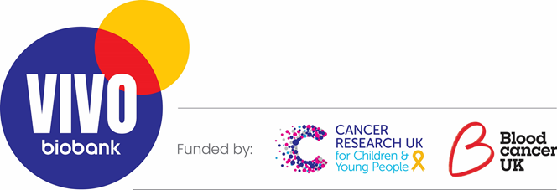***Expressions of interest for membership of the VIVO Biobank***

***Sample and Data Access Committee***

The VIVO Biobank (https://vivobiobank.org/) launched in September 2022 following the merger of the Blood Cancer UK Cell Bank and Cancer Research UK / CCLG Tissue Bank. Now, we are seeking individuals to serve on the Sample and Data Access Committee (SDAC) to oversee the release of samples and data from the VIVO biobank.

**What does the role involve?**

The primary role of members will be to review the applications for samples and/or data that are received by VIVO biobank. Members will assess and score the scientific, clinical or ethical quality of the application depending on each members’ background and expertise. *NB All applications are accompanied by a plain English summary.* In addition, there will be the opportunity to contribute to the overall running of the committee.

**What is the time commitment?**

The committee will run principally via email. Members will need to review applications as and when they are submitted. The average weekly commitment is anticipated to be 1-2 hours. In addition, the committee will meet online every 2 months to discuss larger and more complex applications. Finally, we plan to hold an annual in-person meeting.

**Who we are looking for?**

We are seeking applications from people interested in childhood cancer research including childhood cancer survivors[1], parents, clinicians and scientific researchers.

The committee will comprise

* Two co-chairs – initially Professor Anthony Moorman and Dr Edmund Cheesman
* Six expert reviewers – three clinicians and three scientists covering both solid tumours and leukaemias
* Two PPI members
* Two early career researchers – as observers

**How do I apply?**

Application is via short expression of interest (one side of A4) explaining the reasons why you would be suitable for this role. All applications will be considered by the co-chairs and the successful applicants notified by email. Please note, we are looking to appoint a diverse group of people who reflect the full spectrum of stakeholders in VIVO biobank including early career researchers and clinicians.

Please email your application and contact details to Professor Anthony Moorman (anthony.moorman@newcastle.ac.uk). Please include all relevant experience including reviewing scientific reports/grants.

**The deadline for application is 31st December 2022.**

1. Must be 18 years or old.